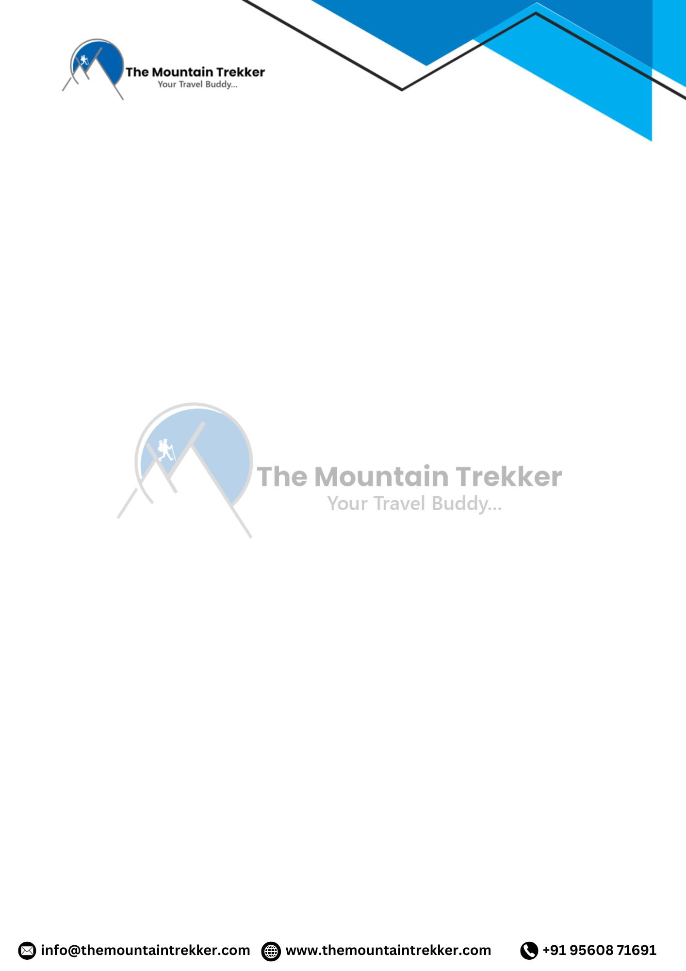
Kedartal Trek
Name: Kedartal Trek
Duration: 5N/6D
Start / End Point: Gangotri / Dehradun
Overview:
The Kedartal Trek, also known as the Kedartal Lake Trek, is a high-altitude adventure through the Garhwal Himalayas in Uttarakhand, India. Starting from Gangotri, the trek passes through dense forests, alpine meadows, and rugged terrain, culminating at the stunning Kedartal Lake at 4,912 meters (16,116 ft). Trekkers experience breathtaking Himalayan peaks like Thalaysagar, Bhrigupanth, and Manda, along with spiritual sites such as Gangotri Temple. The trek is moderately difficult, requiring good physical fitness and acclimatization. Ideal for adventure enthusiasts and those seeking both natural beauty and spiritual exploration.
Best Time to Visit:
May – June, September – October
Difficulty Level:
Moderate to Difficult
Trek Duration:
5 Nights / 6 Days
Altitude:
Max Altitude: 4,912 ft (Kedartal Lake)
Trek Route:
Gangotri → Bhoj Kharak → Kedar Kharak → Kedartal → Gangotri → Dehradun

SHORT ITINERARY
Day 1: Dehradun to Gangotri
Travel Distance: 296 km

- Travel Time: 10–12 hours
- Max Altitude: 3,048 m (10,000 ft)
- Scenic drive through Uttarkashi and Harsil, visit Gangotri Temple. Overnight in guesthouse/homestay.
Day 2: Gangotri to Bhoj Kharak
- Distance Traveled: 8 km
- Time Taken: 4–5 hours
- Altitude Gain: 652 m (2,139 ft)
- Trek through dense forests and meadows, set camp at Bhoj Kharak.
Day 3: Bhoj Kharak to Kedar Kharak
- Distance Traveled: 5 km
- Time Taken: 3–4 hours
- Altitude Gain: 500 m (1,641 ft)
- Steeper terrain with rocky paths; panoramic views of Thalaysagar and Bhrigupanth. Overnight at Kedar Kharak.
Day 4: Kedar Kharak to Kedartal
- Distance Traveled: 5 km
- Time Taken: 4–5 hours
- Altitude Gain: 570 m (1,870 ft)
- Challenging ascent to Kedartal Lake, surrounded by snow-capped peaks. Camp beside the lake.
Day 5: Kedartal to Gangotri
- Distance Traveled: 6–7 hours descent
- Altitude Loss: 1,702 m (5,580 ft)
- Descend to Gangotri; relax and enjoy the scenic views. Overnight in guesthouse/homestay.
Day 6: Gangotri to Dehradun
- Distance Traveled: 296 km
Travel Time: 10–12 hours

- Altitude Loss: 2,448 m (8,032 ft)
- Drive back to Dehradun, trek concludes.

INCLUSION
- Forest permit and entrance fees
- Accommodation in Gangotri (twin/three-share basis) and tents on trek
- Meals: Breakfast, lunch, dinner, tea, coffee, soup, snacks
- Trekking equipment: tents, sleeping bags, mattresses, gaiters/crampons, liners
- Trek leader, technical guide, kitchen team, dining tents, radio walkie-talkie
- Medical kit + oxygen cylinder
EXCLUSION
- Personal insurance and medical expenses
- Transport from Dehradun to Dehradun
- Personal toiletry items
- Meals on the first day (en route) and last day (en route)
- Backpack offloading charges (max 10 kg)
- Any items not mentioned in inclusions

PACKING GUIDE
Clothing:
- Warm layers: jacket, fleece, thermals
- Trek pants and full-sleeve T-shirts
- Socks: sports & woolen
Accessories:
- Sunglasses, sun cap
- Gloves: fleece/wool & waterproof
- Balaclava or woolen scarf
- Trekking stick
Toiletries & Misc:
- Biodegradable toiletries
- Reusable water bottles
- Personal medications
- Documents: passport-size photo, government ID copy, medical certificate, disclaimer form

